Algorithm Efficiency
Some algorithms are more efficient than others. We would prefer to chose an efficient algorithm, so it would be nice to have metrics for comparing algorithm efficiency.
The complexity of an algorithm is a function describing the efficiency of the algorithm in terms of the amount of data the algorithm must process. Usually there are natural units for the domain and range of this function. There are two main complexity measures of the efficiency of an algorithm:

- Time complexity : Time complexity is a function describing the amount of time an algorithm takes in terms of the amount of input to the algorithm. "Time" can mean the number of memory accesses performed, the number of comparisons between integers, the number of times some inner loop is executed, or some other natural unit related to the amount of real time the algorithm will take. We try to keep this idea of time separate from "wall clock" time, since many factors unrelated to the algorithm itself can affect the real time (like the language used, type of computing hardware, proficiency of the programmer, optimization in the compiler, etc.). It turns out that, if we chose the units wisely, all of the other stuff doesn't matter and we can get an independent measure of the efficiency of the algorithm.

The time complexity can now be expressed as function of number of key operations performed. Before we go ahead with our discussions, it is important to understand the rate growth analysis of an algorithm, as shown in following Figure.
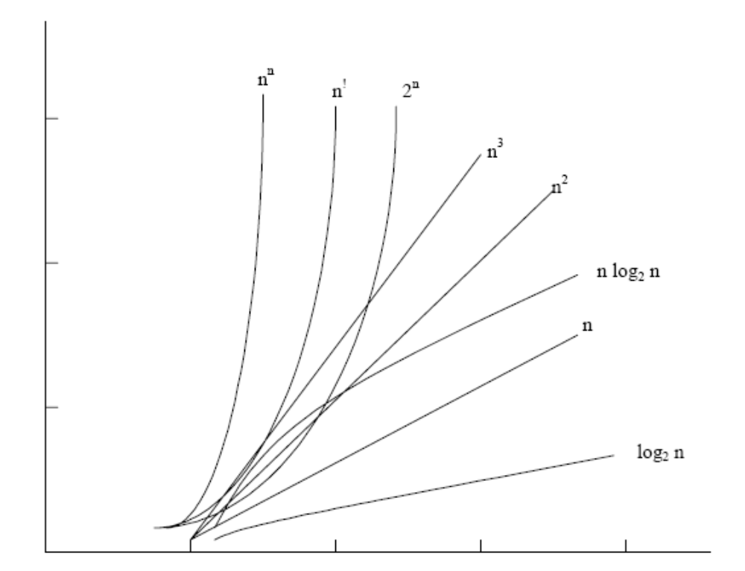

The function that involves ‘n’ as an exponent, i.e., 2n, nn, n ! are called exponential functions, which is too slow except for small size input function where growth is less than or equal to nc,(where ‘c’ is a constant) i.e.; n3, n2, n log2n, n, log2 n are said to be polynomial. Algorithms with polynomial time can solve reasonable sized problems if the constant in the exponent is small. When we analyze an algorithm it depends on the input data, there are three cases :
1. Best case
2. Average case
3. Worst case
In the best case, the amount of time a program might be expected to take on best possible input data. In the average case, the amount of time a program might be expected to take on typical (or average) input data. In the worst case, the amount of time a program would take on the worst possible input configuration.

- Space complexity : Space complexity is a function describing the amount of memory (space) an algorithm takes in terms of the amount of input to the algorithm. We often speak of "extra" memory needed, not counting the memory needed to store the input itself. Again, we use natural (but fixed-length) units to measure this. We can use bytes, but it's easier to use, say, number of integers used, number of fixed-sized structures, etc. In the end, the function we come up with will be independent of the actual number of bytes needed to represent the unit. Space complexity is sometimes ignored because the space used is minimal and/or obvious, but sometimes it becomes as important an issue as time.

For example, we might say "this algorithm takes n² time," where n is the number of items in the input. Or we might say "this algorithm takes constant extra space," because the amount of extra memory needed doesn't vary with the number of items processed.
Think of space efficiency and time efficiency as two opposite ends on a band (a continuum). Every point in between the two ends has a certain time and space efficiency. The more time efficiency you have, the less space efficiency you have, and vice versa. The picture below illustrates this in a simple fashion:

examples:
Algorithms like Mergesort are exceedingly fast, but require lots of space to do the operations. On the other side of the spectrum, Bubble Sort is exceedingly slow, but takes up the minimum of space.
For data trees, 2-3 trees and 2-3-4 trees are faster and more balanced than the normal binary search trees, but they take up an extraordinary amount of space because they usually have tons of unused variables lying around.

- FILE ORGANISATION
File organization can most simply be defined as the method of sorting storing Data record in file in a file and the subsequent implications on the way these records can be accessed. The factors involved in selecting a particular file organization for use are:
- Ease of retrieval
- Convenience of updates
- Economy of storage
- Reliability
- Security
- Integrity
Different file organizations accord the above factors differing weightages. The choice must be made depending upon the individual needs of the particular application in question.
We now introduce in brief the various commonly encountered file organizations.
1. Sequential Files
Data records are stored in some specific sequence e.g. order of arrival value of key field etc. Records of a sequential file cannot be accessed at random i.e. to access the nth record, one must traverse the preceding (n-1) records. Sequential files will be dealt with at length in the next section.
2 Relative Files
Each data record has a fixed place in a relative file. Each record must have associated with it in integer key value that will help identify this slot. This key, therefore, will be used for insertion and retrieval of the record. Random as well as sequential access is possible. Relative files can exist only on random access devices like disks.
3. Direct Files
These are similar to relative files, except that the key value need not be an integer. The user can specify keys which make sense to his application.
4. Indexed Sequential Files
An index is added to the sequential file to provide random access. An overflow area needs to be maintained to permit insertion in sequence.
5. Indexed Flies
In this file organization, no sequence is imposed on the storage of records in the data file, therefore, no overflow area is needed. The index, however, is maintained in strict sequence. Multiple indexes are allowed on a file to improve access.

- SEQUENTIAL FILES
A sequentially organized file may be stored on either a serial-access or a direct-access storage medium.
Structure
To provide the 'sequence' required a 'key' must be defined for the data records. Usually a field whose values can uniquely identify data records is selected as the key. If a single field cannot fulfil this criterion, then a combination of fields can serve as the key. For example in a file which keeps student records, a key could be student no.
Operations
1. Insertion: Records must be inserted at the place dictated by the sequence of the keys. As is obvious, direct insertions into the main data file would lead to frequent rebuilding of the file. This problem could be mitigated by reserving overflow areas' in the file for insertions. But this leads to wastage of space and also the overflow areas may also be filled.
The common method is to use transaction logging. This works as follows:
- collect records for insertion in a transaction file in their order of arrival
- when population of the transactions file has ceased, sort the transaction file in the order of the key of the primary data file
- merge the two files on the basis of the key to get a new copy of the primary sequential file.
Such insertions are usually done in a batch mode when the activity/program which populates the transaction file have ceased. The structure of the transaction files records will be identical to that of the primary file.
2. Deletion: Deletion is the reverse process Of insertion. The space occupied by the record should be freed for use. Usually deletion (like-insertion) is not done immediately. The concerned record (al 9 with a marker or 'tombstone' to indicate deletion) is written to a transaction file. At the time of merging the corresponding data record will be dropped from the primary data file.
3. Updation : Updation is a combination of insertion and deletions. The record with the new values is inserted and the earlier version deleted. This is also done using transaction files.
4. Retrieval: User programs will often retrieve data for viewing prior to making decisions, therefore, it is vital that this data reflects the latest state of the data if the merging activity has not yet taken Place.
Retrieval is usually done for a particular value of the key field. Before return in to the user, the data record should be merged with the transaction record (if any)for that key value.
The other two operations 'creation' and 'deletion' of files are achieved by simple programming language statements.
Disadvantages
Following are some of the disadvantages of sequential file organization:
* Updates are not easily accommodated
* By definition, random access is not possible
* All records must The structurally identical. If a new field has to be added, then every record must The rewritten to provide space for the new field.
* Continuous areas may not he possible because both the primary data file and the transaction file must be looked during merging.
Areas of Use
Sequential files are most frequently used in commercial batch oriented data processing where there is the concept of a master file to which details are added periodically. Ex. payroll applications.
DIRECT FILE ORGANIZATION
It offers an effective way to organize data when there, is a need to access individual records directly.
To access a record directly (or random access) a relationship is used to translate the key value into a physical address. This is called the mapping function R R.(key value) -- Address
Direct files are stored on DASD (Direct Access Storage Device)
A calculation is performed on the key value to get an address. This address calculation technique is often termed as hashing. The calculation applied is called a hash function.
Here we discus a very commonly used hash function called Division - Remainder.
Division-Remainder Hashing
According to this method, key value is divided by an appropriate number, generally a prime number, and the division of remainder is used as the address for the record.The choice of appropriate divisor may not be so simple. If it is known that the file is to contain n records, then we must, assuming that only one record can be stored a given address, have divisor n. Also we may have a very large key space as compared to the address space. Key space refers to all the possible key values. Although only a part of this space will The address space possibly may not match actually be used as key values in the file. the size of key space, therefore a one to one mapping may not be there. That is calculated address may not be unique. It is called Collision, i.e.
R(K1) = R(K2) but K1 = K2
Two unequal keys have been calculated to have the same address. The key are called synonyms.
There are various approaches to handle the problem of collisions. One of these is to hash to buckets. A bucket is a space that can accommodate multiple records.
INDEXED SEQUENTIAL FILE ORGANIZATION
When there is need to access records sequentially by some key value and also to access records directly by the same key value, the collection of records may be organized in an effective manned called Indexes Sequential Organization. You must be familiar with search process for a word in a language dictionary. The data in the dictionary is stored in sequential manner. However an index is provided in terms of thumb tabs. To search for a word we do not search sequentially. We access the index that is the appropriate thumb tab, locate an approximate location for the word and then proceed to find the word sequentially.
To implement the concept of indexed sequential file organizations, we consider an approach in which the index part and data part reside on a separate file. The index file has a tree structure and data file has a sequential structure. Since the data file is sequenced, it is not necessary for the index to have an entry for each record Following figure shows a sequential file with a two-level index. Level 1 of the index holds an entry for each three-record section of the main file. The level 2 indexes level 1 in the same way. When the new records are inserted in the data file, the sequence of records need to be preserved and also the index is accordingly updated.
Two approaches used to implement indexes are static indexes and dynamic indexes. As the main data file changes due to insertions and deletions, the static index contents may change but the structure does not change . In case of dynamic indexing approach, insertions and deletions in the main data file may lead to changes in the index structure. Both dynamic and static indexing techniques are useful depending on the type of application.
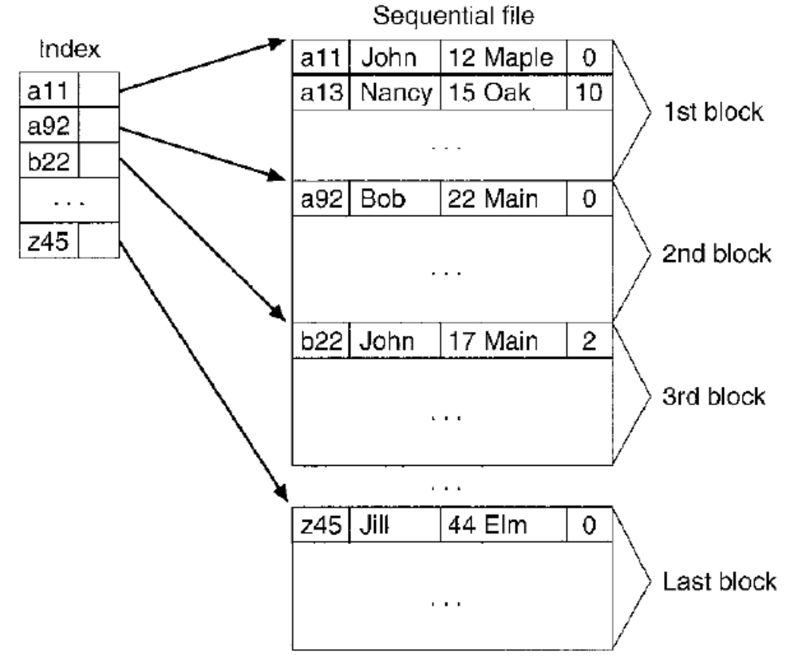
An indexed sequential file.
- Indexed File Organization
A compromise between sequential and direct file organization is Indexed File organization. The data file is written in an order sorted by a Key Field (as with sequential) but also an Index File is created. The Index file is basically a Table consisting of the record’s Keys and a disk location (sector and track on the disk)– and of course the index file is sorted by the same key and is in the same order as the sequential data file An Indexed Sequential file can be accessed in two ways

1. Sequentially reading through each of the records from the beginning in the Main data file – ie exactly the same way as a sequential file
OR
2. Using the Index file (which is a MUCH smaller file) to determine the location on disk of the Record – and then accessing that Record using the Direct manner.

An Indexed file has problems with lots of records that are added and deleted (deleted records are not really deleted – they are “flagged” as deleted) and additions to the file are not placed in sequential order in the main data file – they are placed in any available space – and this is catered for in the Index file.
The Indexed Sequential File is not really suitable for Volatile files (meaning files in which a lot of records are being written and deleted). Using indexes is not as fast as hashing

